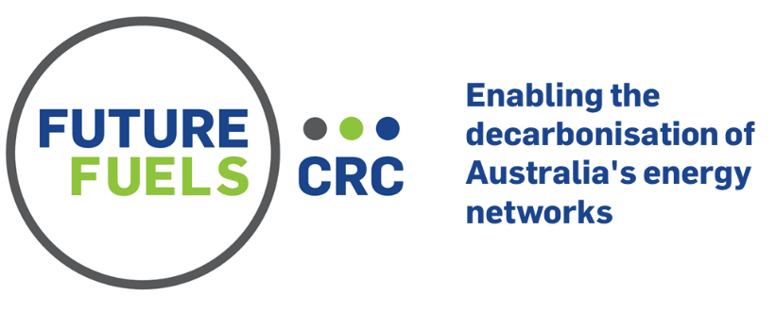

RP1.4-03 — De-risking Hydrogen Adaptation to Industrial Processes
The project aims to de-risk the adaptation of renewable hydrogen fuel to thermal industrial processes in which radiation is a dominant heat transfer mechanism, specifically alumina calciners and cement/lime kilns.
Project Overview
This project produced results from a joint techno-economic (TEA), process modelling and computational fluid dynamics (CFD) analysis on the effect of blending up to 25% by volume hydrogen with natural gas (NG) into the fuel stream on Australian alumina and integrated cement/lime sectors. Preliminary CFD analyses of hydrogen blending on an iron ore pelletiser were also included. In addition, experimental data around blended natural gas / hydrogen flames and probing the efficacy of doping biofuels as an adaptation strategy to enhance visibility and radiant fraction of hydrogen-based flames were also investigated. Furthermore, a preliminary assessment of the ultraviolet (UV) emissions from hydrogen flames was included. Specifically, the following activities were reported:
- First-order techno-economic (TEA) modelling assessing the impact of hydrogen (H₂) blending (up to 25 vol.%) on emission reduction potential, H₂ and NG requirement, H₂ parity cost, and final cost of commodities, for the Australian alumina and integrated cement sectors.
- Process modelling of the impact of H₂ blending (up to 25 vol.%) on performance and operation of an alumina gas suspension calciner.
- CFD modelling of a simplified NG-fired rotary kiln and a commercial NG-fired straight-grate iron ore pelletiser to assess the impact of H₂ blending (up to 25 vol.%) on flame and burner performance.
- Experimental investigation of blended H₂/NG flames and using bio-oil doping as a potential strategy to increase the radiant heat transfer and visibility of H₂ (100%).
- Assessment of the risks of UV emissions from hydrogen flames.
Techno-economic analysis – alumina and cement sectors
For the alumina sector, the emissions reduction potential via H₂ blending up to 25 vol.% into natural gas (NG) was found to be significant in absolute terms, by up to 0.9 MtCO₂-e per year, although its relative impact is relatively low at approximately 6% of the total sector’s CO₂ emissions. In a scenario of 25% H₂ blending by volume, 0.12 Mt of low-carbon H₂ per year—corresponding to half of Australia’s H₂ production in 2020—would be needed to satisfy this energy requirement for the alumina sector. This amount of H₂ blending is expected to have negligible impact on the sale price of the alumina. For integrated cement plants, the economic benefit for H₂ blending is less significant compared with that of alumina production. The estimated emissions reduction potential associated with H₂ blending (up to 25 vol.%) was found to be fifty times less in absolute terms than for alumina (up to 0.02 MtCO₂-e per year), and also an order of magnitude less in relative terms (only 0.4% of the total sector CO₂ emissions, due to the majority of the emissions being derived from the limestone itself) and because the natural gas to be replaced with H₂ only accounts for 20% of the total energy consumed by sector (with coal still being the predominant fuel). This indicates that the cement sector is not likely to benefit significantly from a H₂ blending strategy in terms of decarbonisation. The TEA suggests that blending is likely to be economically feasible for the case of alumina production even though, for both the alumina and cement sectors, the parity cost for H₂ to displace natural gas (NG) is around 1–2 A$/kg for a NG price of 9–18 A$/GJ.
Process modelling – alumina calciner
The process modelling of the last step of the alumina Bayer process also demonstrates that this step can be undertaken with H₂ blends (up to 25 vol.%) with negligible changes on product quality and process performance, and with no modification to current operations and plant layout needed (other than changes to plant equipment to accommodate H₂ in the valves and flowmeters).
Computational models – cement kiln and iron ore pelletiser
The CFD analysis of a simplified NG-fired rotary kiln burner configuration identified that H₂ blending by up to 10 vol% will introduce only relatively small changes to the flame and burner performance. On the other hand, for the 25% H₂ blending scenario, a significant increase in NOx emissions (70% increase in comparison with the baseline case being NG-only) was found to be likely, indicating that appropriate NOx control strategies would likely be needed to accommodate this level of H₂ blending. The analysis also showed that burner modifications are likely to be able to overcome this increase. For example, reducing the primary air ratio was found to significantly reduce the NOx emissions for the H₂ blended fuel for the burner configuration assessed here. Similar results were also found for an iron ore pelletiser. Nevertheless, these details are all configuration specific, so would need to be optimised on a case-by-case basis.
Experimental investigation –characterisation of hydrogen / natural gas flames
A series of experimental investigations quantified the effects of hydrogen addition into a range of burners under industry relevant conditions, each of which include the testing of a potential solution strategy to overcome one or more of the challenges associated with the use of hydrogen. The diverse burner designs and experimental methods chosen provides both specific and general understanding of the implications of hydrogen addition to industrial burners, as well as valuable and novel insights to how hydrogen might be more smoothly integrated into the current gas infrastructure. This work has been published as:
- Performance of biogas blended with hydrogen in a commercial self-aspirating burner, International Journal of Hydrogen Energy. DOI: 10.1016/j.ijhydene.2023.11.322
- Characterisation of turbulent non-premixed hydrogen-blended flames in a scaled industrial low-swirl burner, International Journal of Hydrogen Energy. DOI: 10.1016/j.ijhydene.2023.11.164
- Hydrogen addition to a commercial self-aspirating burner and assessment of a practical burner modification strategy to improve performance, International Journal of Hydrogen Energy. DOI: 10.1016/j.ijhydene.2023.06.230
- Toluene addition to turbulent H₂/natural gas flames in bluff-body burners, International Journal of Hydrogen Energy. DOI: 10.1016/j.ijhydene.2022.06.154
- Fundamental insights into the effect of blending hydrogen flames with sooting biofuels, Fuel. DOI: 10.1016/j.fuel.2022.125618
- Hydrogen turbulent nonpremixed flames blended with spray or prevapourised biofuels, International Journal of Hydrogen Energy. DOI: 10.1016/j.ijhydene.2023.03.232
UV emissions from hydrogen flames
The initial scoping results from flame spectrometry and irradiance measurements indicate that UV emissions from hydrogen flames are moderately higher than from natural gas flames, but still orders of magnitude less than the UV outside on an overcast day, where sun protection is generally not needed. On this basis, while hydrogen does emit a greater amount of radiation in the UV region compared with natural gas flames, this does not appear to be significant from a human skin exposure standpoint.
Acknowledgements
The project team included representatives from: The University of Adelaide, Woodside, GPA Engineering, Fyfe Engineering, FCT Combustion, Australian Gas Infrastructure Group, South Australian Office of the Technical Regulator, Jemena. In addition to the Future Fuels CRC partners, valuable contributions were provided by Rio Tinto and Adbri.
Future Fuels CRC is supported through the Australian Government’s Cooperative Research Centres Program. We gratefully acknowledge the cash and in-kind support from all our research, government and industry participants.



