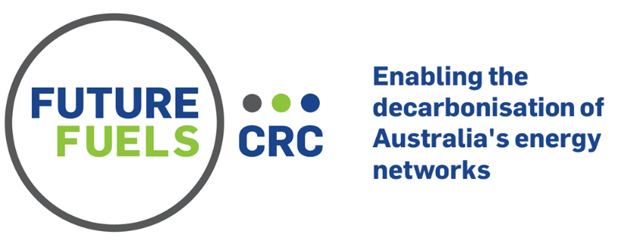

RP2.3-03: Establishing a Case-Based Learning Framework for Pipeline Engineers
RP2.3-03 sought to establish a case-based learning framework, firstly by looking systematically at what lessons need to be learned by pipeline engineers, and associated capabilities developed, to maintain the industry’s public safety record. Secondly, the project then used this understanding to identify and begin to scope a program of case-based learning experiences (professional learning modules) which are informed by appropriate education models to support the best engineering decision making for public safety.
A related project output was the development of a set of past accident cases for use in an identified suite of training options to be delivered in a future phase of this work (see RP2.3-07).
Industry need
Though the Australian gas industry has a generally excellent record of the when it comes to public safety and security of supply, the move to future fuels and the increasing integration of energy networks challenges individuals who work in the pipeline engineering profession to maintain their capacity for making excellent engineering decisions that can impact system integrity.
Additionally, in order to maintain the pipeline sector’s excellent public safety record there is a need for professional development activities to address both technical competencies (which is the usual focus) and relevant non-technical capabilities. For example, high-quality decision-making requires additionally skills for making the best choices in complex situations of significant uncertainty.
Research activities and outcomes
As noted above, a key focus of this project was the scoping of education modules for professional learning to advance non-technical capabilities. Two methods were used to ground the choices that were made about the learning objectives and the required capabilities in professional practice:
- Literature review: the researchers conducted a review of pipeline engineering practices for public safety and associated capability needs; and
- Undertaking fieldwork which principally involved interviews with pipeline engineers.
A related professional learning design framework was developed and guided this process. This framework has the following six stages:
- Needs identification;
- Learning objectives and outcomes development;
- Professional capability identification;
- Identification of educational approach;
- Identification of appropriate learning activities and content material; and
- Evaluation strategy.
The research identified six overarching non-technical professional capabilities:
Capability | Related interview themes
- Use long term, foresighted reasoning, especially in the face of uncertainty | - Imagining worst case outcomes  - Choosing with the long term in mind  - Dealing with uncertainty
- Understand norms and values that inform actions | - Using standards  - Understanding risk processes and concepts  - Making ethical choices
- Think systematically and understand interconnectedness | - Understanding context  - Prioritising actions in complex situations  - Applying risk concepts  - Taking enough time
- Collaborate with and draw on the experience of others | - Build networks or seek others’ opinions  - Knowing your limitations  - Building a good relationship with field people  - Building external stakeholder relationships
- Ground decisions in reality | - Making practical choices  - Learning from small failures  - Be sceptical of models and calculations  - Imagine being there
- Advocate for action and take responsibility | - Influencing senior management and clients  - Standing up for public safety

Additionally, the final project report details the project’s key conclusions regarding:
- The educational approach that forms the foundation of the proposed learning modules, drawing on theory of education and the interview data;
- Learning activities that are suitable for developing the identified capabilities, learning objectives, and outcomes (in this work experiential case-based learning is the focus). Different approaches to case based learning are noted and reviewed – e.g. role play, simulation, game building, group-based reasoning, and film and live performance; and
- Appropriate content material for the modules (past accident cases).

Different case pairs were identified/prioritised for different targeted training participants:
- For transmission pipeline engineers a combination of the San Bruno disaster and the Challenger space shuttle loss provide a pair of cases that cover all capabilities and include one case from the sector and one from a very different sector; and
- For distribution sector engineers, a similar pair of cases are the Massachusetts gas distribution system failure and the Dreamworld accident. Again, these cases cover all capabilities between them and include one case with familiar technology and one that is from a different sector.

The following learning module options for further development were proposed (also see RP2.3-07)
- Option 1a: Discussion and role play (transmission pipeline engineers) – face-to-face or online
- Option 1b: Discussion and role play (distribution system engineers – face-to-face or online
- Option 2: The Pipeline Game - A game/simulation for groups of players (either face to face or online) to make decisions impacting safety through the lifecycle of an imaginary pipeline and see the consequences of their choices play out as the game proceeds.

Acknowledgements
The project was led by research team comprised of staff from RMIT (Jan Hayes, Sarah Holdsworth, Orana Sandri, Janice Wong) and University of Canberra (Sarah Maslen), who were supported by industry advisors from Sage Consulting, EPIC Energy, GPA Engineering, ESV, and Spiecapag.

Future Fuels CRC is supported through the Australian Government’s Cooperative Research Centres Program. We gratefully acknowledge the cash and in-kind support from all our research, government and industry participants.

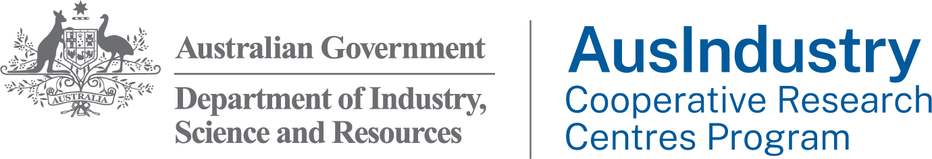

Also see https://link.springer.com/article/10.1007/s10111-022-00702-6

